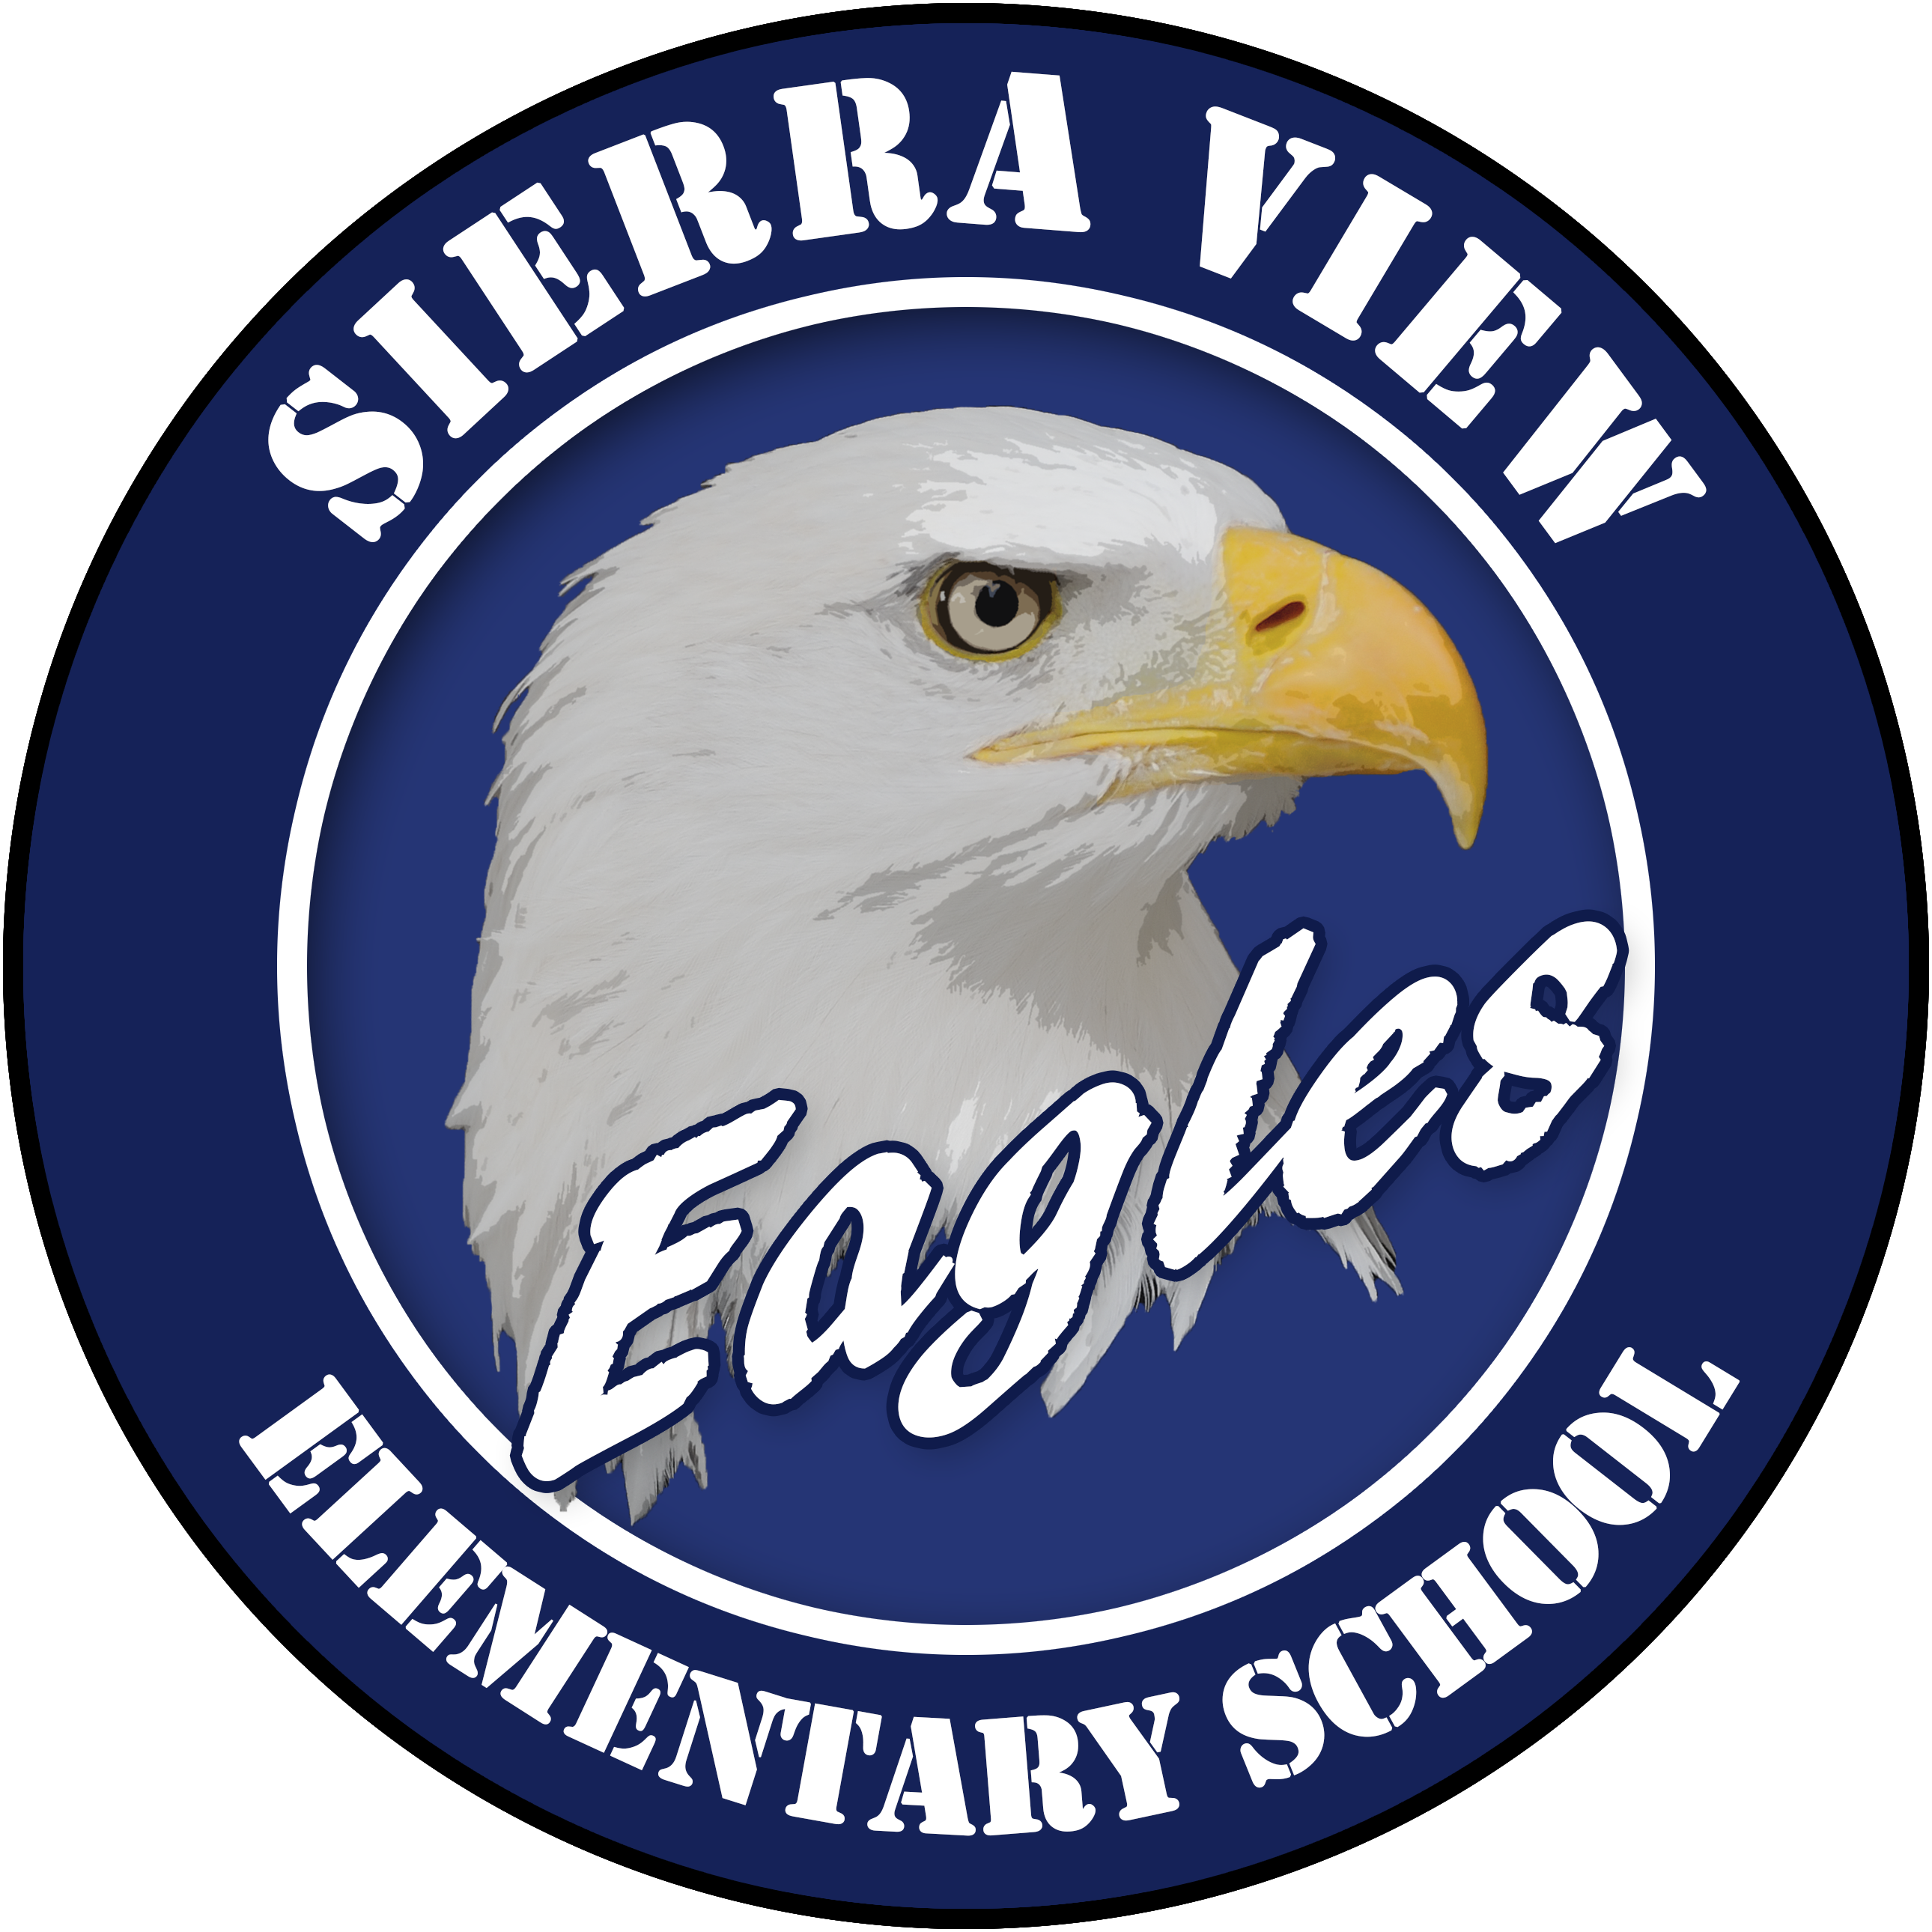
Sierra View
Elementary School

Bell Schedule 2023-2024

TRANSITIONAL KINDERGARTEN/KINDERGARTEN  8:00…………Supervision Begins  8:20 - 9:20….…Class  9:20 - 9:40…..Recess  9:40 - 11:25……Class  11:00 – 11:45…TK Lunch  11:25 - 12:05…..Kinder Lunch  12:05 - 1:30…...…Class  1:30 – 1:40…..Recess  1:40 – 2:15….…Class  2:15……Dismissal  Total Instructional Minutes = 255 | FIRST GRADE  8:00…………Supervision Begins  8:30 – 9:45……..…..Class  9:45 – 10:05……...Recess  10:05 – 11:25…………Class  11:25 – 12:05………..Lunch  12:05 – 1:10…………..Class  1:10 – 1:20……...Recess  1:20 – 2:25………..Class  2:25………Dismissal  Total Instructional Minutes = 285
SECOND & THIRD GRADES  8:00…………….Supervision Begins  8:30 – 9:45……..Class  9:45 – 10:05….Recess  10:05 – 11:45……..Class  11:45 – 12:25……Lunch  12:25 – 1:10….…..Class  1:10 – 1:20…..Recess  1:20 – 2:25……..Class  2:25…….Dismissal  Total Instructional Minutes = 285 | FOURTH & FIFTH GRADES  8:00…..………Supervision Begins  8:15 – 10:10……..Class  10:10 – 10:30…..Recess  10:30 – 12:05……..Class  12:05 – 12:50…...Lunch  12:50 – 2:25….…..Class  2:25……Dismissal  Total Instructional Minutes = 305

