Sierra View
Elementary School

Parent & Student Handbook

Revised 2023

Sierra View Elementary School

1598 Hooker Oak Avenue
Chico, California 95926
(530) 891-3117
Principal: Kimberly Rodgers

Chico Unified School District

1163 E. Seventh Street
Chico, CA 95928
(530) 891-3000
Kelly Staley, Superintendent

School Mascot
American Bald Eagle “Swoop”

School Colors
Blue and White

Mission and Vision

Our Mission is to
Spark a joy for learning
Build a foundation for knowledge and skill
Create a safe and respectful environment
Promote lifelong learners and productive contributors to society

Our Vision is to
provide a nurturing environment where students, staff,
and parents work cohesively and effectively towards specific goals
allowing all students to reach their fullest potential

School Profile

Sierra View is a neighborhood school serving students in transitional kindergarten through fifth grades. We take great pride in our Academic Plus program that strongly focuses on providing rigorous instruction in reading, writing and math, rounded out by a solid curriculum in composition, science, history and geography. We are committed to developing the whole child. The Academic Plus program is designed to instill within each child confidence, a sense of responsibility, pride in accomplishment and a positive self-image through academic achievement. Our classroom setting utilizes large group interaction, targeted small group instruction and independent seatwork to help make the learning experience exciting and enjoyable. The average class size is twenty-four students in transitional kindergarten through third grades and thirty students in fourth and fifth grades. Our focus is centered around four questions:

- What do we want students to learn?
- How will we know when they have learned it?
- How will we respond if they do not learn it?
- How will we further challenge students when they do learn it?

Our Dedicated Staff

Sierra View’s dedicated staff includes one Site Administrator, twenty-three full-time General Education teachers in kindergarten through fifth grade. We have one full-time Resource Specialist teacher (RSP) and two moderate/severe teachers, and one Speech and Language Specialist who serve all students who have an Individual Education Plan (IEP). District support is given with a one-day-a-week School Psychologist. Butte County Office of Education also provides support with Occupational Therapy, Visually Impaired, Adaptive P.E, etc.

Sierra View has two Fine Arts Specialists that provide visual and performing arts lessons in transitional kindergarten through fifth grades. We also have one P.E./Health Specialist who provides physical education activities and health lessons to first through fifth graders and one Music teacher who works with all students in transitional kindergarten through fifth grades.

In addition, we have a Teacher/Student Support teacher that assists teachers in creating an intervention plan for students with specific academic and social emotional needs and a Reading Specialist that provides targeted instruction to students who qualify based on specific criteria and results from assessment data. We have three general education Instructional Paraprofessionals and two Parent Classroom Aides.

We also have one School Counselor and Counseling Assistant who provide individual and small group support, and social emotional lessons to all students. Our full time Targeted Case Manager acts as the bridge between school and home, making sure parents feel more connected to the school community and resources available in the community where we live.

Sierra View’s team includes many support staff. This team includes one Office Manager, one full-time Attendance Clerk, one part-time Health Assistant and a Nurse one day a week. Our Computer Technician manages our technology devices, provides support for teachers and students as well as instruction in the classroom. Sierra View’s Library Aide supports students and staff by over-seeing the library media center. This includes circulation and maintenance of the library materials. Our Cafeteria Manager and Assistant provide nutritious breakfasts and lunches daily. Lastly, we have one Senior Custodian working full-time during the school day, one full-time night custodian and one part-time night Custodian.

School Staff
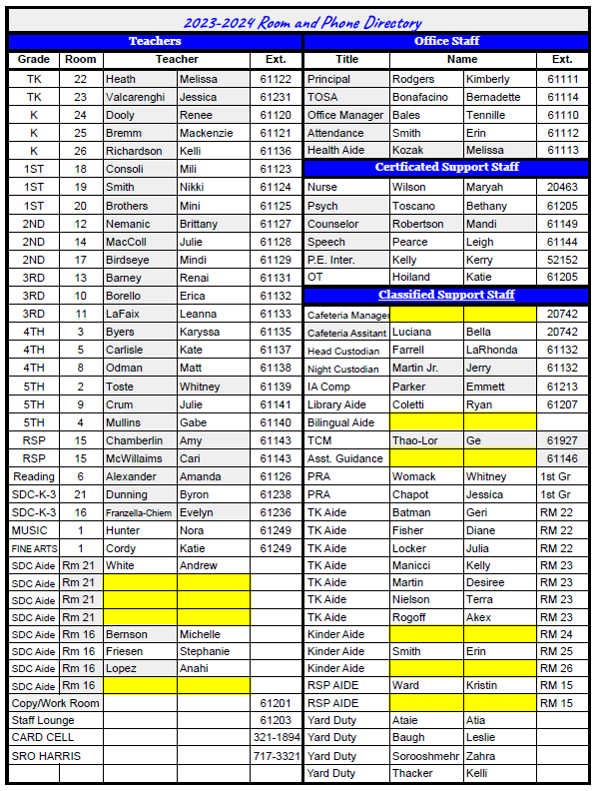

Bell Schedule
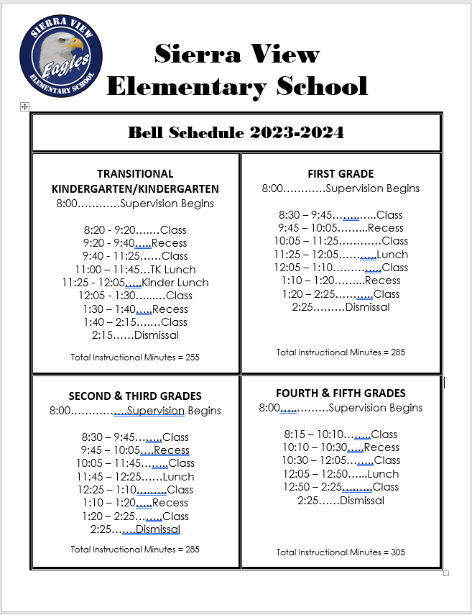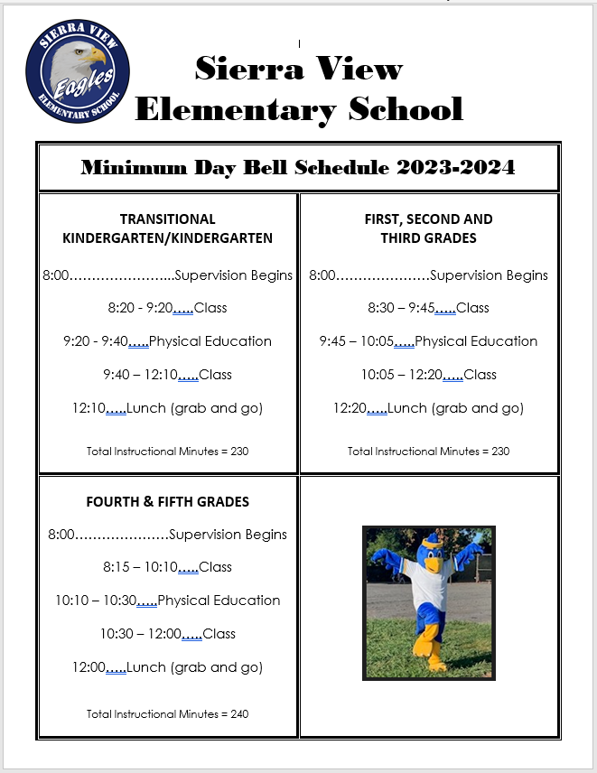

Arrival and Dismissal From School
Breakfast served daily in the cafeteria between 7:30-8:15 AM

Normal School Day

Arrival
- 1st-5th grade students may arrive at 7:30 AM. Students who arrive between 7:30-8:00 AM must go to the cafeteria entering through the door located on the parking lot side of the cafeteria.
- Supervision on the playground begins at 8:00 AM
- Kindergarten students must remain in the cafeteria until class begins at 8:10
- 1st-5th grade students will remain in the cafeteria until 8:00 AM.
- 1st-5th grade students who arrive after 8:00 AM need to enter the campus through the designated gates and proceed to the playground
- Kg-1st grade- Main gate in front of the school
- 2nd-3rd grade- gain located between the cafeteria and the computer lab
- 4th-5th- gate located near the bike racks

Dismissal
- Students who do not ride the bus are asked to go directly home or to be picked up by parents at dismissal time. There is no student supervision past 2:45 after school. Please pick your child up promptly.
- We ask that students make all arrangements for going home prior to that school day (i.e., going to Billy's after school), as the office phone is for emergencies only. If plans change, call the school 10 minutes before dismissal and your call will be transferred to the classroom.
- Any students remaining on campus after 2:45 will be taken to the office to wait for pick up. Kindergarten students are dismissed at 2:10 p.m. Students must be picked up at this time. Please wait for 1st through 5th grade students off campus. There is no parking, stopping or dropping off in the red zone in front of the school at any time. The white zones are for dropping off or picking up only. You cannot leave your vehicle or stop for longer than 3 minutes in the white zones. Please instruct your students to use the crosswalks at all times when crossing the street.

Rainy Day

Arrival
- All students who arrive between 7:30-8:15 AM need to report to the cafeteria and will be excused as follows:
- Kindergarten students must remain in the cafeteria until class begins at 8:10 AM
- 2nd-3rd grade students must remain in the cafeteria until 8:15 AM and go directly to class when excused
- 4th-5th grade students must remain in the cafeteria until 8:00 AM and go directly to class when excused

Dismissal
- Students must go home immediately after dismissal exiting from designated gates:
- Kg-1st grade- Main gate in front of the school
- 2nd-3rd grade- gain located between the cafeteria and the computer lab
- 4th-5th- gate located near the bike racks

Everybody Has Responsibilities

The school’s responsibilities:

- Endeavor to motivate students to learn through interesting and challenging lessonsPromote student achievement
- Have high expectations, and help every child develop a love of learning
- Communicate regularly with families
- Provide a safe and caring learning environment
- Consistently work with families and school colleagues to make school accessible and welcoming place
- Respect the school, students, staff and families

The parent’s responsibilities:

- Be aware of grade level requirements
- Assist your child(ren) with homework as needed
- Review and sign Weekly Reports
- Support school/teacher discipline plan
- Help maintain home/school communication
- Support the Academics Plus Program by being involved whenever possible

The student’s responsibilities:

- Understand what skills are required
- Attend school regularly and on time, except when ill
- Do the work assigned in class and as homework
- Be attentive during class time
- Follow school/classroom behavior standards
- Deliver messages between parents and school
- Bring home Weekly Reports, show them to parents and return them to school
- Accept responsibility for my actions

School-Wide Discipline Plan
Sierra View uses a school-wide approach for encouraging positive behavior. This approach is known as PBIS, or Positive Behavioral Interventions and Supports. Positive Behavioral Interventions and Supports (PBIS) is an evidence-based three-tiered framework for improving and integrating all of the data, systems, and practices affecting student outcomes every day. It is a way to support everyone – especially students with disabilities – to create the kinds of schools where all students are successful. PBIS is a commitment to addressing student behavior through systems change. When it’s implemented well, students achieve positive social and academic outcomes and school experiences. We also experience a reduced number of discipline incidents and suspensions. In addition, school personnel feel more effective.

Throughout the school year we focus on teaching the students the school wide expectations; Be Safe, Observe Rules, Aim for Academic Success, and Be Respectful and Responsible (SOAR). The expectations for all common areas are discussed and shared with all students and personnel on our campus. Below you will find a copy of our Sierra View Elementary School-Wide Behavior Expectations SOAR Matrix. Please look it over so you and your family can become familiar with the expectations at Sierra View Elementary.

In order to foster safe, responsible, and respectful students we have a Minor Citation/ Major Referral form (definitions) and data tracking system called eduCLIMBER. This will help to identify the where, when, why, who, and what needs to be retaught. School staff will be looking intently at “where” and “why” problems are occurring on our campus and how to prevent problems from arising. We take pride in having a “no violence” policy, so that every student feels safe and respected.

It is important for families to understand that the PBIS framework is designed to maximize positive academic and social behavioral outcomes to ensure the success of all Sierra View students. We are so lucky to have a wonderful school family here at Sierra View, thanks to all of you and your willingness to work together as a cohesive team.

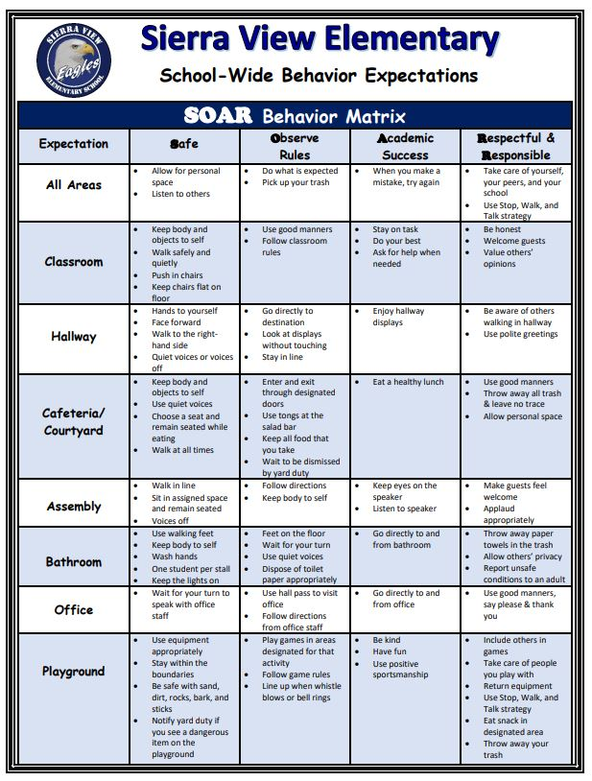

Student Academic & Social-Emotional Support

MTSS

Library Support
The library is available to all students during their class library time and for research at the teacher’s discretion. It is the student's responsibility to return his/her library book when it is due. If a student loses or damages a book the student and their family are responsible for the replacement of that book. Our library is also open to all students during lunch and recess.

Wellness Center Support

The Wellness Center is open to all and by focusing on building relationships with all students. Our goal is to begin to erase the stigma associated with addressing and maintaining social and emotional well-being by normalizing use of the WC and wellness services. We are finding that students enjoy accessing the center and are now viewing the WC as a resource and referring their friends as well!

We invite you to stop by the Wellness Center in Room #27 or contact our Wellness Center Coordinator and School Counselor, Mandi Robertson, to ask any questions you may have about Wellness Services. Please read on to learn more.

Who is in the Wellness Center?

Name | Role | Days | Hours
Mandi Robertson  Ms. Mandi | School Counselor/Wellness Center Coordinator  (Check-Ins, individual and group counseling, SEL for grades 4 & 5, new student orientations, Lunch Bunch, conflict mediations) | Monday-Friday | 8-2:30
 | Counseling Assistant  (SEL, Friendship Groups, Lunch Bunch) | Monday-Friday | TBD
Ge Thao Lor  Ms.Ge | Targeted Case Manager (TCM)  (assisting families in accessing resources) | M/W/F | M/W: 7:30-4:00  F: 12pm - 4pm

How is the Wellness Center Accessed?
- Drop-In – Students may drop in (as long as a Wellness staff member is present) before school from 8AM - 8:15 (Intermediate) and 8AM - 8:30 (Primary). Students may use this time to let staff know they need a check-in that day, to socialize and engage in supported play with their peers, and/or to prepare themselves for the day in a way that works best for them.

- Drop-In per Teacher Request – Students may ask to go to the Wellness Center to check-in or use the Zen Zone or a staff member may identify it as a useful brief intervention after other classroom interventions have been made.

- Planned Services (Staff or Family Referral) – Include individual and group counseling, PALS/POP programming, and Friendship Groups. Students receiving these services are referred by any stakeholder to the Wellness Team and arranged by one of the WC staff and communicated with teacher and family. Permission forms are required.
- Other Services: Initiated by Wellness Team or other SV staff and include check-ins, new student orientations, Lunch Bunch and conflict mediations.

What are the Wellness Activities & Services?
Social Emotional Learning (SEL): These are 30-40 minute lessons provided in the classroom on a weekly basis by Ms. Mandi (Grades 4 & 5) or Ms. Lewis (Grades K-3).
Group Counseling: 30 minutes sessions facilitated by Ms. Mandi for groups of 3-4 students focused on a variety of different topics based on areas of need including social skill development, emotional regulation, self-esteem building, anxiety management, etc.
Individual Counseling: 30 minute, 1:1 counseling sessions facilitated by Ms. Mandi to address specific areas of need.
Friendship Group: 30 minutes sessions facilitated by Ms. Lewis for groups of 3-4 students focused on peer interactions and relationship building.
POP/PALS: Child directed play with 1-2 children and a counseling assistant with a focus on relationship and social skill development.
Lunch Bunch: Students are invited to bring a friend(s) to enjoy lunch in the WC. Students may be chosen strategically to assist with social connectedness, to reward progress on a goal, to give students a needed boost to look forward to, or simply to increase comfort with accessing the WC.
Check-In: 15 minute meeting for any student requesting a check-in or identified as a student in need of support. Staff and parents/guardians often refer students for check-ins when they are coping with loss, transitions, and other challenging life events. Students may self-refer by asking a teacher, stopping by the WC, or completing the ‘Student Check-In’ form on the SV website under ‘Wellness’.
Conflict Mediations: Processing and discussion facilitated by Ms. Mandi and involves two or more students experiencing conflict who may have self-referred or referred by staff/guardians.
New Student Orientation: 15 minute introduction and tour of the WC facilitated by Ms. Mandi for every new student within 1-2 weeks of enrolling at SV.

Wellness Services are designed to cultivate healthy relationships with others, increase mental health awareness, validate emotions and experiences, and to support the well-being of the whole child.

School Information

Student Classroom Placement
The Sierra View Elementary staff meet in late May to determine classroom placement for the following school year. Teachers and administration work together to determine the best placement for your student. As a staff we believe that group dynamics highly affect instruction and individual performance. Our teaching staff will place your child in a classroom creating a cohesive environment, which will foster your child’s success. Each classroom will be balanced for academic ability, gender, special needs students, positive leaders, and students with behavior issues. This careful consideration will ensure that each student in every classroom will meet his/her learning potential. Teacher assignments may change during July due to students transferring in and out of our school. For this reason, final lists are not available until 4:00 PM on the school day prior to the first day of school through the Parent Portal.

School Site Council
The School Site Council (SSC) is the governing board for this program. The School Site Council consists of a committee of parents and staff members elected by their peers. The Council works on planning, implementing, and evaluating the school program. The SSC meets at minimum 3-4 times per year; September, December, March and May (subject to change as needed).

Textbooks in compliance with the Williams Act:
Textbooks are provided for each student. Students will be held responsible for the care of books assigned to them. If a book is lost or damaged, it is the responsibility of the student to pay for the book. All books must be accounted for before promotion or transfer.

Dress Code
The Board of Education has adopted a policy which states that students’ dress and grooming is the responsibility of parents. Since the manner in which students dress for school can influence behavior and learning, we encourage a parent to dress their children in neat, clean clothing appropriate for elementary school activities. Clothes shall be sufficient to conceal undergarments at all times and clothing such as see-through or fish-net fabrics, halter tops, low cut tops, spaghetti strap tank tops, bare midriffs, sagging pants or pants that drag on the ground causing a safety hazard, and short shorts or skirts that are shorter than their hands dropped at their sides are prohibited. For reasons of health/safety and Education Code provisions, all students will wear appropriate footwear. Platform, open-toed, and backless footwear are prohibited. Make-up may not be worn at school. Hats will be permitted as protection from cold weather and sun. They may not be worn backwards or inside buildings. Hat privileges may be revoked if individuals compromise the hat policy. Crude printing, pictures depicting or encouraging drugs, tobacco, alcohol, racial-ethnic slurs, gang affiliation, or that are sexually suggestive on any apparel are not acceptable. The school will notify parents in the event a child’s dress or grooming is not deemed acceptable or appropriate for school.

Harassment - Free Learning Environment
All members of the school community; students, faculty, classified staff, and administrators are protected by state and federal law from discrimination, harassment and retaliation on the basis of race, national origin, sex, age, disability and other protected status. Chico Unified School District has a discrimination and harassment policy and a complaint procedure for students, which was developed to provide information and guidelines regarding the law and the proper procedure for addressing inappropriate conduct directed toward them by their peers or district staff. You may request a copy of this policy by calling the District’s personnel office at 891-3000, ex. 142 or visiting the Sierra View front office.

Lost and Found
Lost and Found clothing items are kept in the Multipurpose Room. Small and valuable items are kept at the office. Please encourage your child to check the Lost and Found on a regular basis. The PTO donates the clothing from the Lost and Found to charities every trimester. Please label all clothing, lunch boxes and personal school materials with your child’s first and last name.

Safety Information
Chico Unified School District has developed a School Safety Plan for all schools. The plan includes disaster preparedness drills and emergency plans for students, staff and members of the public. School Plans are reviewed annually with teachers and students in order to ensure effective action in the event of a school emergency or disaster.

Animals
Animals are not to be brought to school. Please do not bring dogs on campus before or after school or on the weekends. Dogs are not allowed on campus. Service animals must have the required paperwork prior to visiting.

Classroom Parties
District policy allows classrooms to have two parties per year, which are determined by the teacher. Please check with your student’s teacher in advance regarding any individual celebrations. We ask that you not send party invitations to your child’s classroom for parties to be held outside of school hours unless you are inviting the entire class. Classroom parties will be required to follow the district’s wellness policy.

Toys
Toys and electronic instruments (cell phones, MP3 players, headsets, fidget spinners, yo-yos, trading cards, etc.) cause distraction in the classroom and on the playground, and can be costly to students if they are lost. Please leave toys, etc. at home unless the teacher has approved the item for sharing. The school will not be responsible if any of the above items are lost or stolen.

Cell Phones
If cell phones are brought to school they must remain in the student’s backpack and turned off. If phones are seen at any time during the school day, they will be taken and placed in the office where they can only be retrieved by a parent. The school will not be responsible if a phone is lost or stolen. If a student needs to make a phone call, classroom phones may be used with permission from the teacher. Students may use the office phone for emergency situations with permission from the office staff.

Dress Code
The Board of Education has adopted a policy which states that students’ dress and grooming is the responsibility of parents. Since the manner in which students dress for school can influence behavior and learning, we encourage a parent to dress their children in neat, clean clothing appropriate for elementary school activities. Clothes shall be sufficient to conceal undergarments at all times and clothing such as see-through or fish-net fabrics, halter tops, low cut tops, spaghetti strap tank tops, bare midriffs, sagging pants or pants that drag on the ground causing a safety hazard, and short shorts or skirts that are shorter than their hands dropped at their sides are prohibited. For reasons of health/safety and Education Code provisions, all students will wear appropriate footwear. Platform, open-toed, and backless footwear are prohibited. Make-up may not be worn at school. Hats will be permitted as protection from cold weather and sun. They may not be worn backwards or inside buildings. Hat privileges may be revoked if individuals compromise the hat policy. Crude printing, pictures depicting or encouraging drugs, tobacco, alcohol, racial-ethnic slurs, gang affiliation, or that are sexually suggestive on any apparel are not acceptable. The school will notify parents in the event a child’s dress or grooming is not deemed acceptable or appropriate for school.

Bicycles, skateboards, Scooters, etc:
You may ride to and from school on a bicycle, skates or scooter; however, the following are to followed at all time between the hours of 7:30 AM - 6:00 PM
- Bikes, skates, scooter, etc. are to be kept out of the hall and walkways at all times
- Students are not to tamper with bikes or scooters, nor loiter near the bike racks.
- Bicycles, etc. must be “walked” while on sidewalks or paths on or near the school grounds.

Attendance and Absences

The California Education Code requires that children between the ages of 6-16 attend school. The only acceptable excuses for not being in attendance are illness, doctor or dental appointments, etc. If your child is absent, please send a WRITTEN NOTE IN THE DAY YOUR CHILD RETURNS TO SCHOOL OR PHONE THE ATTENDANCE LINE AT 891-3117 X 60112. Please state specifically the nature of the illness, i.e. “Jim had a cold”. If you choose to send a note, please date and sign the note.

If it is necessary for your child to be excused for dental or medical appointments, send a written note of explanation on the day the child is to be excused. Children will not be excused unless a proper verification of the absence is made.

Children will not be released during school hours for private music or dancing lessons.

Sierra View is involved in the Attendance Program which monitors and reviews all attendance problems. Conferences will be held with pupils who are having serious attendance problems.

Student Work Make-Up Policy
Teachers at Sierra View will be responsible for providing work ahead of time for only those students who will be absent from school for an “excused” reason (i.e. illness or family emergency). Those students whose absences are “unexcused” will be responsible for making up all the work missed after they have returned.

While instruction and learning activities from the teacher are by far the best way for students to learn, we do realize that families sometimes need to be out of town during school time. We provide Independent Study if a student is out of school for 5 or more days. Parents and student will sign a contract with the principal a week or more before the trip, then the teacher will get a week’s or more of school work together. When the student returns with the work completed, the student will get credit for being at school (no absence!) and the school will get ADA. This is a win-win for both the student and the school.

The School Attendance and Review Team (SARB) will be responsible for judging any absence “excused” or “unexcused” in any case that is questionable.

Tardies:
A Student is tardy when he/she arrives in the classroom after the tardy bell rings but before the first thirty minutes of the class has been completed. A student is habitually tardy to a class when he/she receives six or more unexcused tardies per semester.

A student who is absent from school without a valid excuse in excess of thirty (30) minutes or more per day for three different days during the school year will be declared a truant, and the parents will be notified of their obligation to resolve the truancy problem. A student with more than five unexcused absences will be declared a habitual truant and the parents will be invited to attend a conference to discuss resolution of the truancy problem.

Transfers
If you anticipate a change of residence, please notify the school as soon as possible so that all paperwork and records may be prepared as accurately as possible. Children who move from the Sierra View attendance area will be transferred to the school within which the new residence is located, if families choose not to attend Sierra View any longer.

Parents as Partners

The parent community at Sierra View Elementary is a key factor contributing to our positive school’s culture and student success.Parent participation in their child’s education is highly encouraged and welcomed! We welcome your support and commitment by becoming a part of our school community. Studies show the more a parent is involved in their child’s education the more successful their child will be. We value partnership in promoting your child’s academic and social-emotional success at Sierra View.

The School Site Council and Parent Teacher Organization (PTO) give educational program support. The School Site Council (SSC) meets at least 3 times a year. This council is made up of half parents and half school staff. This committee provides input into the development of the Single Plan for Student Achievement and decides how categorical money is to be spent (LCAP, Safe Schools, and Title II).

Sierra View’s PTO is composed of parents and teachers working together to make our children’s stay at Sierra View a more enriched educational experience. These include supporting fundraising efforts to support teachers in the classroom; with supplies and money to go on fieldtrips and to support school-wide activities. Support is also provided to run our Primary Behavior Support Program (PBIS); purchasing prizes for monthly drawings, Pop Fridays, Big Spin, etc. Funding from PTO also is donated to purchase office supplies, copy machine paper, and so much more.

Teachers, parents, relatives, neighbors and friends are encouraged to support the work of this organization by becoming PTO members during the membership drive each fall (or any other time during the school year). All parents are invited to the meetings to make suggestions, voice concerns, or simply keep informed about school activities. A schedule of meetings is posted in the Sierra Viewer and is available on the PTO Bulletin Board. Please contact PTO President Heather Keller with questions or concerns.

Parent Teacher Organization

President: Melissa Kozak

Treasurer: Danielle Hilson

Vice-President : Desiree Wilson-Membership

Vice-President: Tennille Bales-Programs

Mallory Bodney-Programs

Auditor/Asst Treasurer: Whitney Womack

Recording Secretary: Amy Chamberlin

Parliamentarian: Sara Harkness
Social Media: Ashley Kearns
Staff Liaison: Mackenzie Bremm

Grading and Reporting to Parents

Grading is a vital part of the school communication process. All children are evaluated on everything they do in meeting the requirements of their grade level. Evaluation is an on-going process which provides a record of the degree of each child’s success and growth made in all aspects of the school setting. This record indicates strengths, weaknesses, needs in specific skill areas, needs for reteaching, and the degree of understanding of new concepts.

Each child’s record of success is dependent upon many factors:

Intellectual Attitudes

Reading performance Interest in school

Ability to think critically Parental interest and influence

Ability to master principles independently Interest in the subject

Cognitive ability Ability to learn from mistakes

Ability to understand and Desire to learn

apply new concepts

Self-concept Self-responsibility

Child’s concept of self as a worthwhile Use of class time and completion of work

member of his class

Child’s concept of self as contributing Study habits and following

member of his family directions

Child’s physical and emotional health Ability to concentrate

The evaluation record (report card) is a means of communicating with parents. It not only indicates the level of performance of the child, but also serves as a way for parents to learn of the on-going programs of the school. Parents may request a more specific analysis of a problem or come in for more frequent reporting. The evaluation record should encourage parents to increase communication with the teacher for maximum growth on the part of your child.

Parking Lot Guidelines

Our parking lot is a very busy place before and after school and when kindergarten is dismissed. Please help us by adhering to the designated use of lanes:

- The lane nearest the building “drop-off and Pick-up only DO NOT PARK AND LEAVE YOUR VEHICLE in this lane.
- The middle lane is NO STOPPING. This must be left free for through traffic.
- If you are to park and leave your car, even if it’s “just for a minute”, PLEASE PARK WHERE YOU ARE NOT OBSTRUCTING ANOTHER VEHICLE, Please us the visitor or unlabeled space, or park along the curb on Hooker Oak Avenue or Madrone Avenue.

Your cooperation will help keep our school community safe and will assist us in ensuring drop-off and pick-up times run smoothly.

Immunization Statement

The State Department of Health Services, in consultation with the State Department of Education, has the responsibility for developing and enforcing regulations which specify the immunization required for school admission. Children starting Kindergarten must have a record of their immunizations at the time of registration. Please note the following
Required Immunizations:
- DTP/Td (Diphtheria-Tetanus-Pertussis) – At least four doses. If the fourth or last dose was administered before four years of age, an additional dose is required.
- Polio – At least three doses. If the third or last dose was administered before four years of age, one additional dose is required.
- Measles – Rubella – Mumps – Two doses of each, separately or combined, on or after the first birthday.
- Hepatitis B – Series of 3
- Varicella (Chickenpox) – immunization or Dr. signature that student has had the disease.

Knives, Firearms, Explosives and Other Weapons

Section 48915 of the Education Code states that students are to be immediately suspended and be recommended for expulsion if they are found to be in possession of a firearm, knife of no reasonable use to the pupil, or explosive at school or at a school activity off school grounds. Education Code 48900 (b) states “possessed, sold, or otherwise furnished any firearm, knife, explosive, or other dangerous object unless, in the case of possession of any object of this type, the pupil had obtained written permission to possess the item from a certificated school employee, which is concurred by the principal or the designee of the principal”. The Board of Education determines the results of the recommendation for a student’s expulsion from school.

Parties

Three classroom parties are allowed each class. The responsibility for parties is divided between the PTO room parents and teachers as follows: Teacher (and class, when appropriate) selects the days and activities; Room Parents provide refreshments and help as needed. Sierra View promotes healthy eating and requests that healthy snacks be brought (see website for suggestions).

PARTIES AT HOME – Unless all children in the class are invited, party invitations may not be delivered at school – they must be mailed instead. Teachers will be able to supply a list of names only of children in the class.

Health Services

Our health services are supervised by a school nurse who screens children for hearing and vision problems. The nurse is available by appointment for health screening and consultation. Vision is screened in kindergarten and grades 2 and 5. Hearing is tested in kindergarten and 2nd. We have a Health Aide on duty at Sierra View from 8:30 until 2:15 who is trained in first aid and handles most of the daily problems that occur.

Our Office Manager is also trained in CPR/First Aid and handles problems when the Health Aide in not on duty.

No one at school may diagnose any illness or injury nor may administer any medication, including aspirin without an official authorization form, signed by a physician and the parent. Forms for authorization to Give Medication at School are available in the school office. These forms are taken to your doctor and then returned to the school where they are kept on file. Medication kept at school must be in a prescription bottle.

Emergency Information

In case of illness or injury to a child, every effort will be made to contact the parent by telephone. It is important that your home and business numbers and the telephone number and name of your physician, be on the Emergency/Enrollment Card kept in the school office.

Please notify the school immediately of any change in all emergency telephone numbers, address change, and physician telephone number.

It is important to tell your child when he/she leaves in the morning if you expect to be away from home for any length of time during the school day. Please see that the office has a number to call in emergencies.

If you wish to contact your child or to withdraw your child from school please come to the office. We want to know who is in our school. In this way, we can prevent unauthorized persons from loitering around our children. We don’t know everyone, so please don’t be offended if you are asked to identify yourself. We will not release children from school except to the parents or legal guardian of the child concerned.

